Coincident Intersection

Definition
# Source: AI Source: Provided by: [Data Path: Persons Table -> ID Column: 1, Name_En Column: Motasem Essam] -> From: [ChatGPT] on [7/25/2026]
Coincident Intersection occurs when two geometric objects lie exactly on top of each other, so that every point of one object is also a point of the other.
In other words, the two objects completely coincide.
For two identical line segments:
$$\boxed{\overline{AB}∩\overline{AB}=\overline{AB}}$$
The intersection is therefore the entire segment, not a single point.
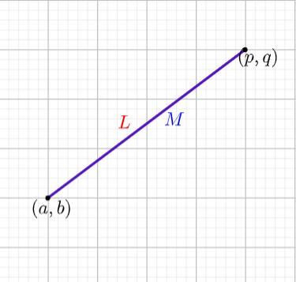
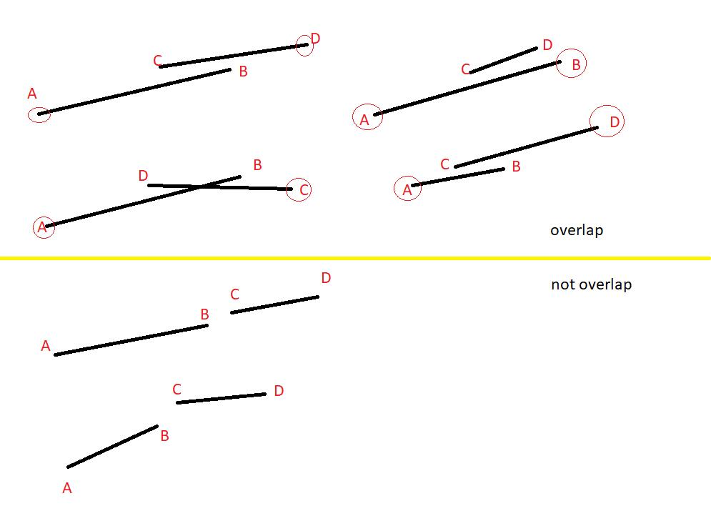
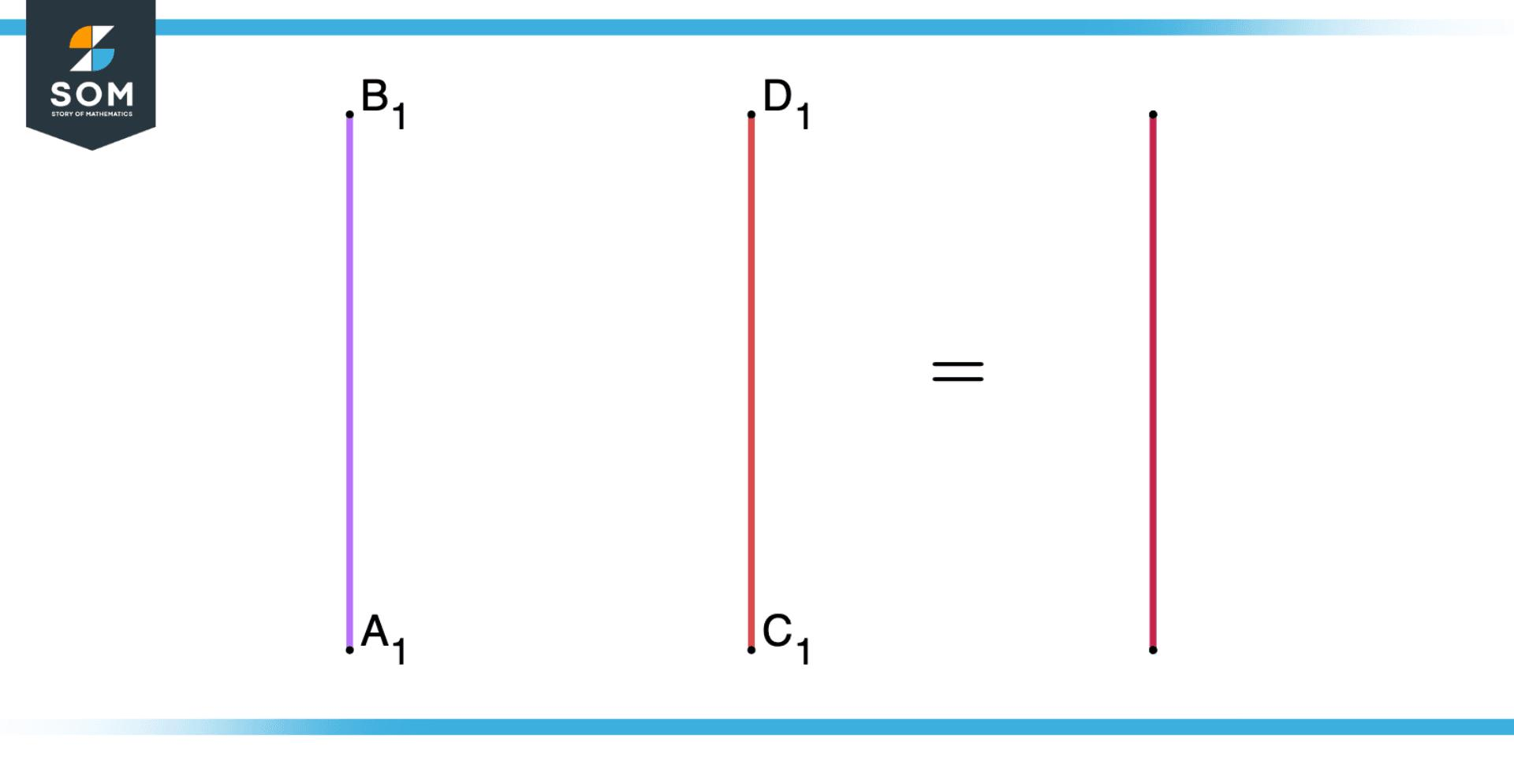

Purpose
# Source: AI Source: Provided by: [Data Path: Persons Table -> ID Column: 1, Name_En Column: Motasem Essam] -> From: [ChatGPT] on [7/25/2026]
Coincident intersection is used to:
- Identify geometric objects that occupy exactly the same location.
- Detect duplicate geometric elements.
- Determine whether two lines or segments are identical.
- Analyze shared boundaries.
- Identify completely overlapping edges.
- Support CAD and GIS operations.
- Simplify geometric models.
- Detect duplicate paths and boundaries.

Fundamental Idea
# Source: AI Source: Provided by: [Data Path: Persons Table -> ID Column: 1, Name_En Column: Motasem Essam] -> From: [ChatGPT] on [7/25/2026]
The key idea is:
$$\boxed{\text{Coincident objects have the same geometric location}}$$
For example:
A────────────────B
A────────────────B
The two segments occupy exactly the same position.
Therefore:
$$\boxed{\overline{AB}∩\overline{AB}=\overline{AB}}$$
Every point on the first segment is also on the second segment.

Mathematical Representation
# Source: AI Source: Provided by: [Data Path: Persons Table -> ID Column: 1, Name_En Column: Motasem Essam] -> From: [ChatGPT] on [7/25/2026]
If two geometric objects A and $B$ are coincident:
$$\boxed{A=B}$$
and therefore:
$$\boxed{A∩B=A=B}$$
For coincident line segments:
$$\boxed{\overline{AB}∩\overline{CD}=\overline{AB}}$$
provided that:
$$\boxed{\overline{AB}=\overline{CD}}$$

Coincident Line Segments
# Source: AI Source: Provided by: [Data Path: Persons Table -> ID Column: 1, Name_En Column: Motasem Essam] -> From: [ChatGPT] on [7/25/2026]
Consider two identical segments:
A────────────────B
A────────────────B
They have:
- The same starting point.
- The same ending point.
- The same direction.
- The same length.
- The same location.
Therefore, they are coincident segments.
$$\boxed{\overline{AB}=\overline{CD}}$$
and:
$$\boxed{\overline{AB}∩\overline{CD}=\overline{AB}}$$
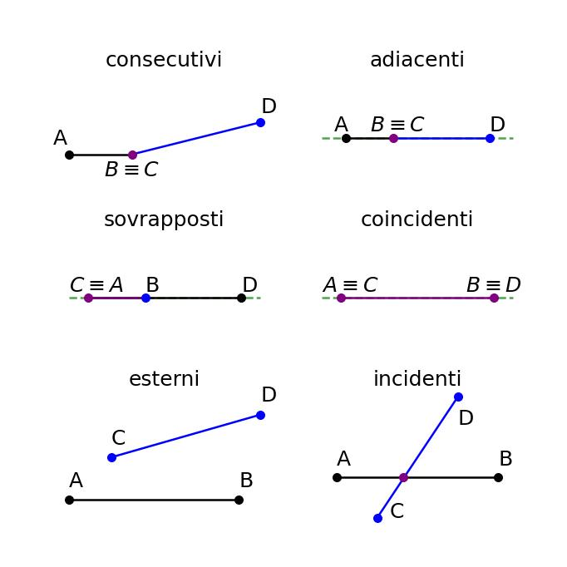
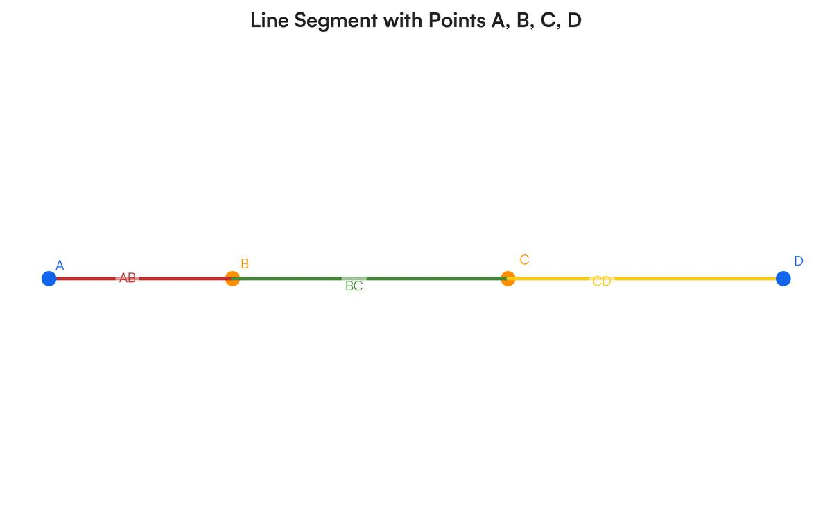

Coincident Lines
# Source: AI Source: Provided by: [Data Path: Persons Table -> ID Column: 1, Name_En Column: Motasem Essam] -> From: [ChatGPT] on [7/25/2026]
Two infinite lines are coincident when they are actually the same line.
For example:
────────────────────────────────
────────────────────────────────
Although they may be represented using different names, they occupy exactly the same set of points.
If:
$$l_{1}=l_{2}$$
then:
$$\boxed{l_{1}∩l_{2}=l_{1}=l_{2}}$$
Therefore, the intersection contains infinitely many points.
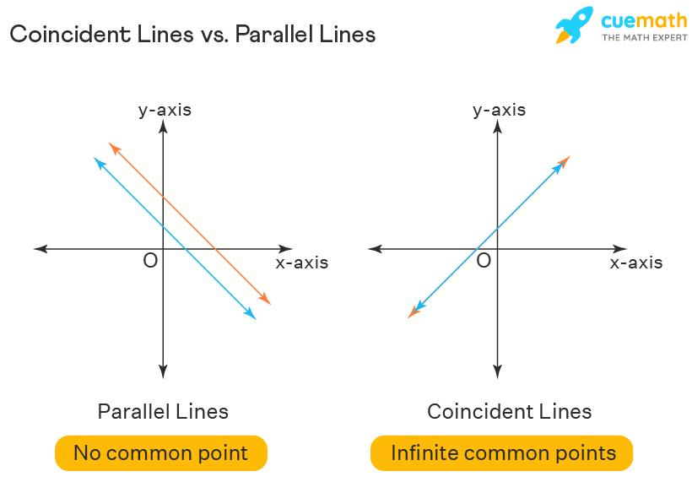
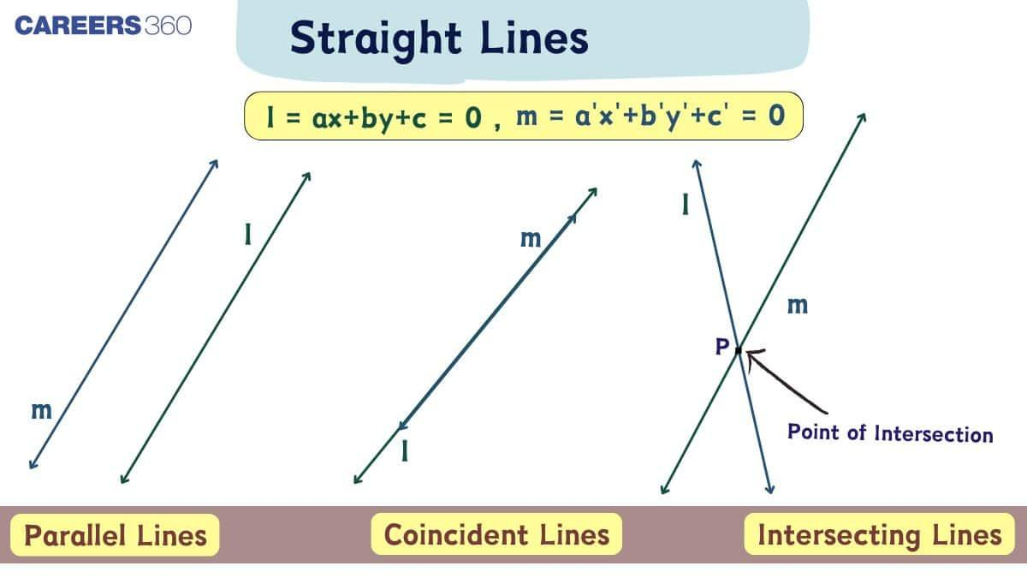
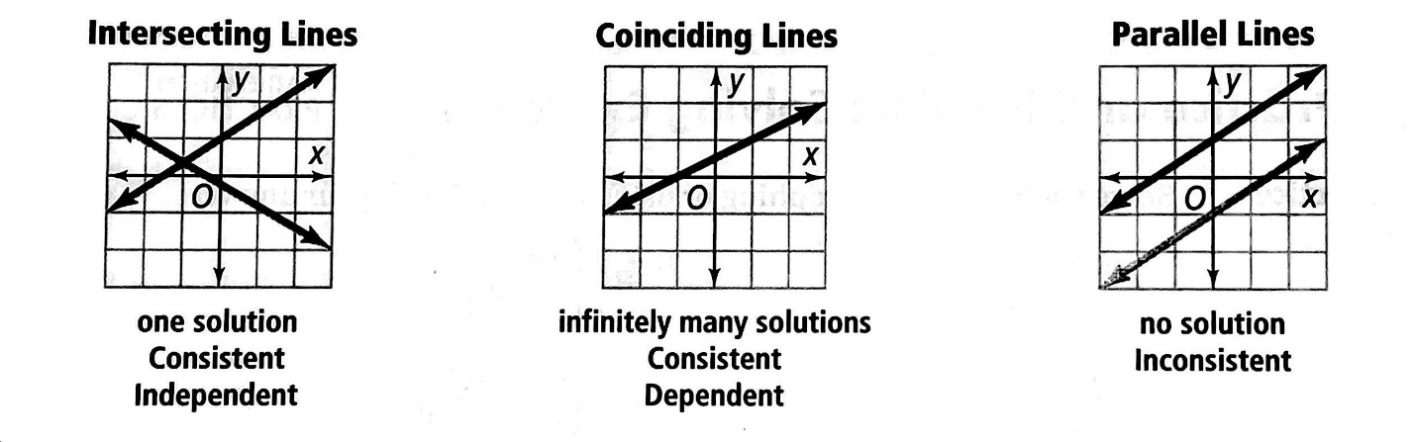
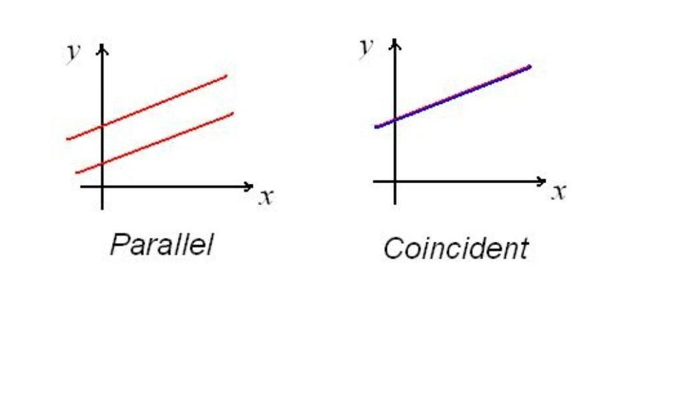
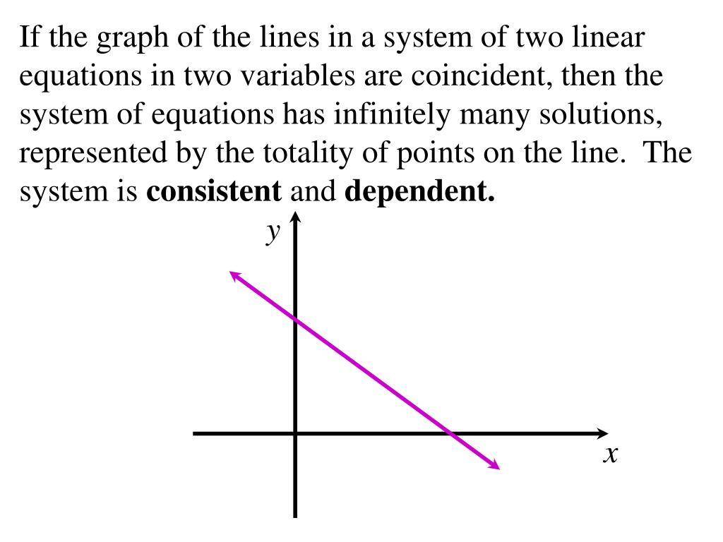

Coincident Rays
# Source: AI Source: Provided by: [Data Path: Persons Table -> ID Column: 1, Name_En Column: Motasem Essam] -> From: [ChatGPT] on [7/25/2026]
Two rays can also be coincident.
For example:
A──────────────→
A──────────────→
If both rays have the same endpoint and extend in exactly the same direction, they are coincident.
Thus:
$$\boxed{\vec{AB} = \vec{AC}}$$

if $B$ and $C$ lie in the same direction from $A$.
Their intersection is the entire ray:
$$\boxed{\vec{AB}∩\vec{AC}=\vec{AB}}$$

Coincident Segments vs. Overlapping Segments
# Source: AI Source: Provided by: [Data Path: Persons Table -> ID Column: 1, Name_En Column: Motasem Essam] -> From: [ChatGPT] on [7/25/2026]
These concepts are closely related but are not exactly the same.
Coincident Segments
The two segments are completely identical.
A────────────────B
A────────────────B
$$\boxed{\overline{AB}∩\overline{CD}=\overline{AB}}$$
Partially Overlapping Segments
Only part of the segments is common.
A────────────────B
C────────────────D
$$\boxed{\overline{AB}∩\overline{CD}=\overline{CB}}$$
Therefore:
$$\boxed{\text{Coincident}=\text{complete overlap}}$$
while:
$$\boxed{\text{Overlapping}=\text{partial or complete shared portion}}$$
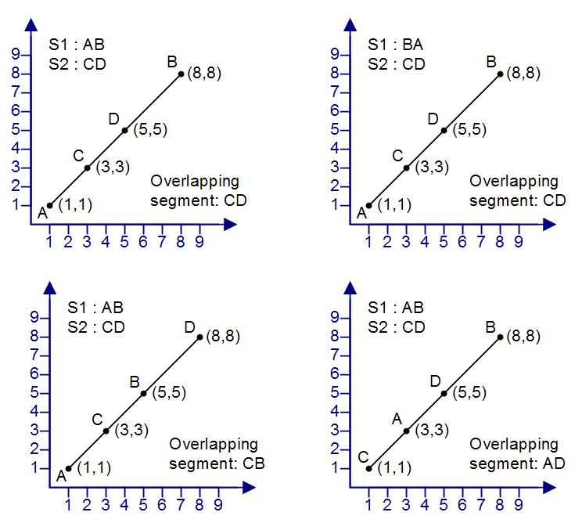

Coincident Intersection vs. Point Intersection
# Source: AI Source: Provided by: [Data Path: Persons Table -> ID Column: 1, Name_En Column: Motasem Essam] -> From: [ChatGPT] on [7/25/2026]
Point Intersection
Two objects share exactly one point:
$$\boxed{A∩B=P}$$
Coincident Intersection
Two objects share an entire geometric object:
$$\boxed{A∩B=A}$$
For a line, this means infinitely many common points.
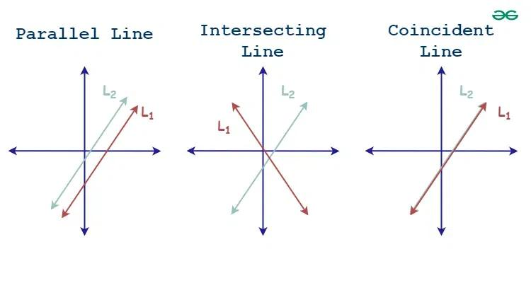
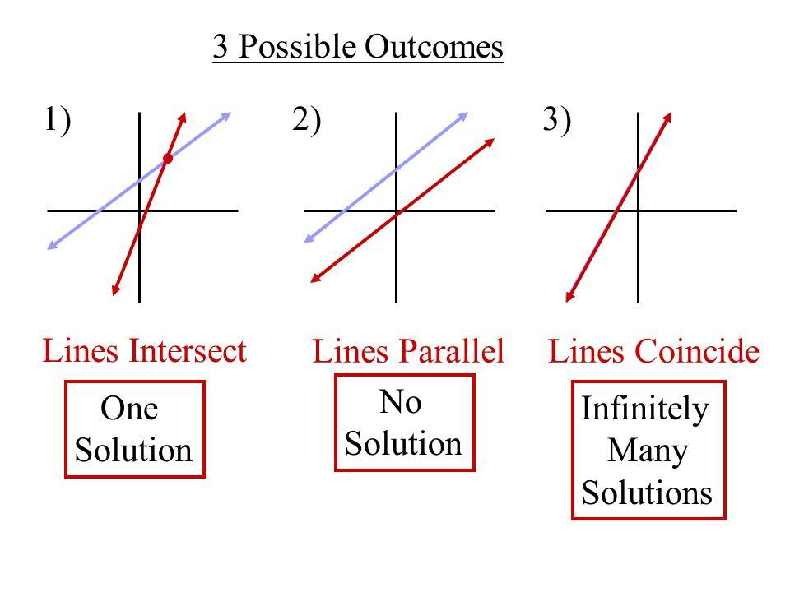

Coincident Intersection vs. Endpoint Intersection
# Source: AI Source: Provided by: [Data Path: Persons Table -> ID Column: 1, Name_En Column: Motasem Essam] -> From: [ChatGPT] on [7/25/2026]
Endpoint Intersection
Two segments share only an endpoint:
$$\boxed{\overline{AB}∩\overline{CD}=P}$$
Coincident Intersection
Two segments share their entire length:
$$\boxed{\overline{AB}∩\overline{CD}=\overline{AB}}$$
Therefore:
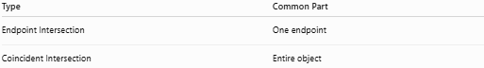
Type | Common Part
Endpoint Intersection | One endpoint
Coincident Intersection | Entire object

Coincident Intersection vs. No Intersection
# Source: AI Source: Provided by: [Data Path: Persons Table -> ID Column: 1, Name_En Column: Motasem Essam] -> From: [ChatGPT] on [7/25/2026]
No Intersection
$$\boxed{A∩B=∅}$$
There are no common points.
Coincident Intersection
$$\boxed{A∩B=A}$$
All points are common.
These are opposite situations.

Coordinate Geometry
# Source: AI Source: Provided by: [Data Path: Persons Table -> ID Column: 1, Name_En Column: Motasem Essam] -> From: [ChatGPT] on [7/25/2026]
Coincident lines can be identified using their equations.
Suppose:
$$y=2x+3$$
and:
$$2x-y+3=0$$
Rearranging the second equation:
$$y=2x+3$$
Therefore, both equations describe exactly the same line.
Hence:
$$\boxed{l_{1}=l_{2}}$$
and:
$$\boxed{l_{1}∩l_{2}=l_{1}}$$
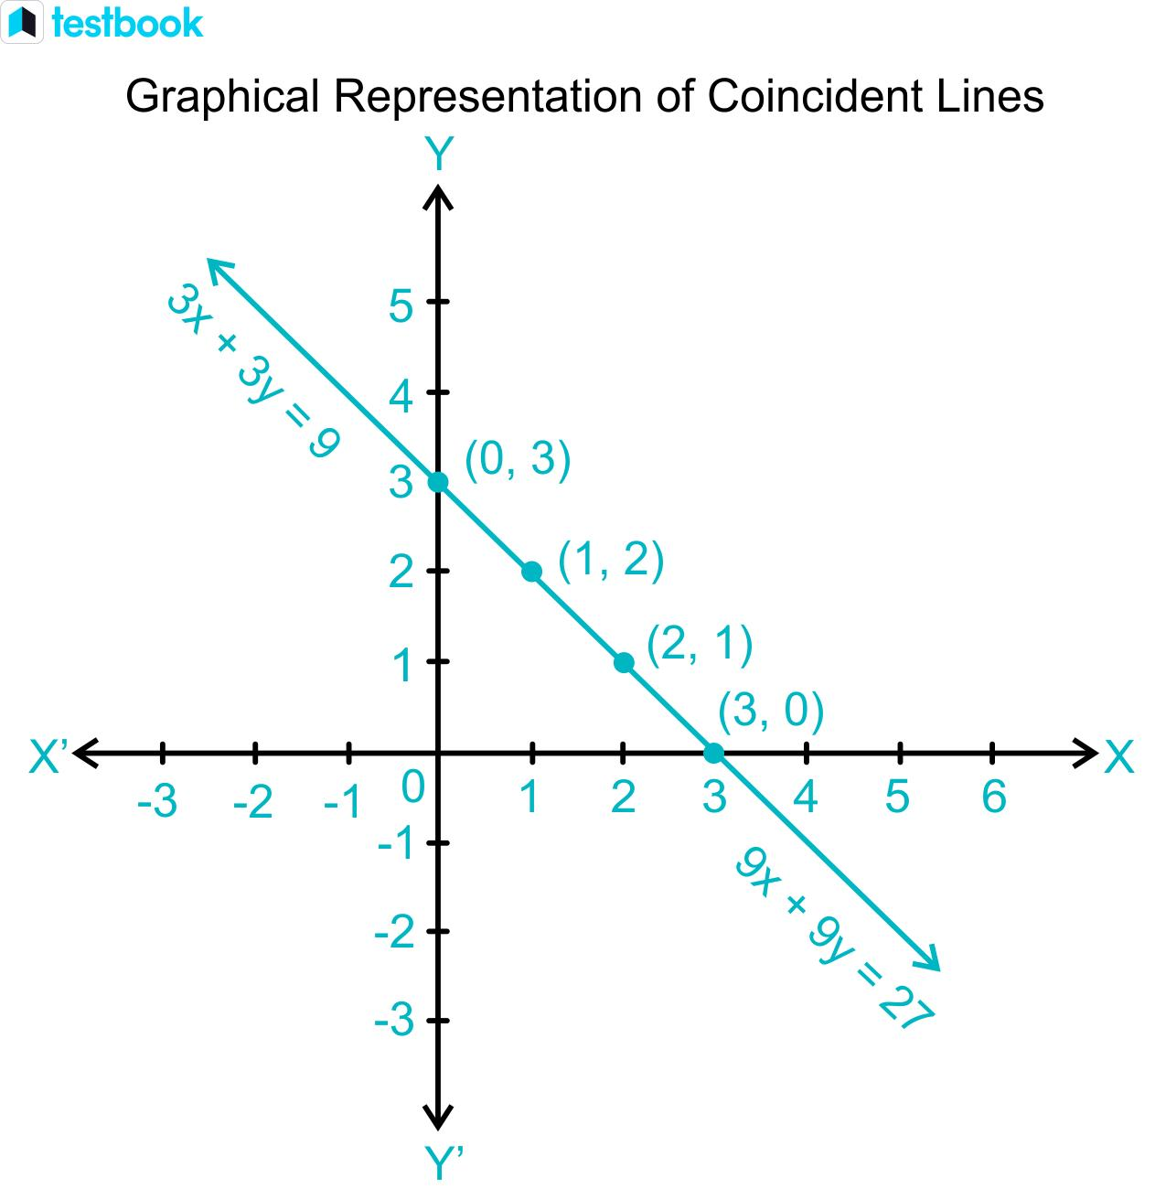
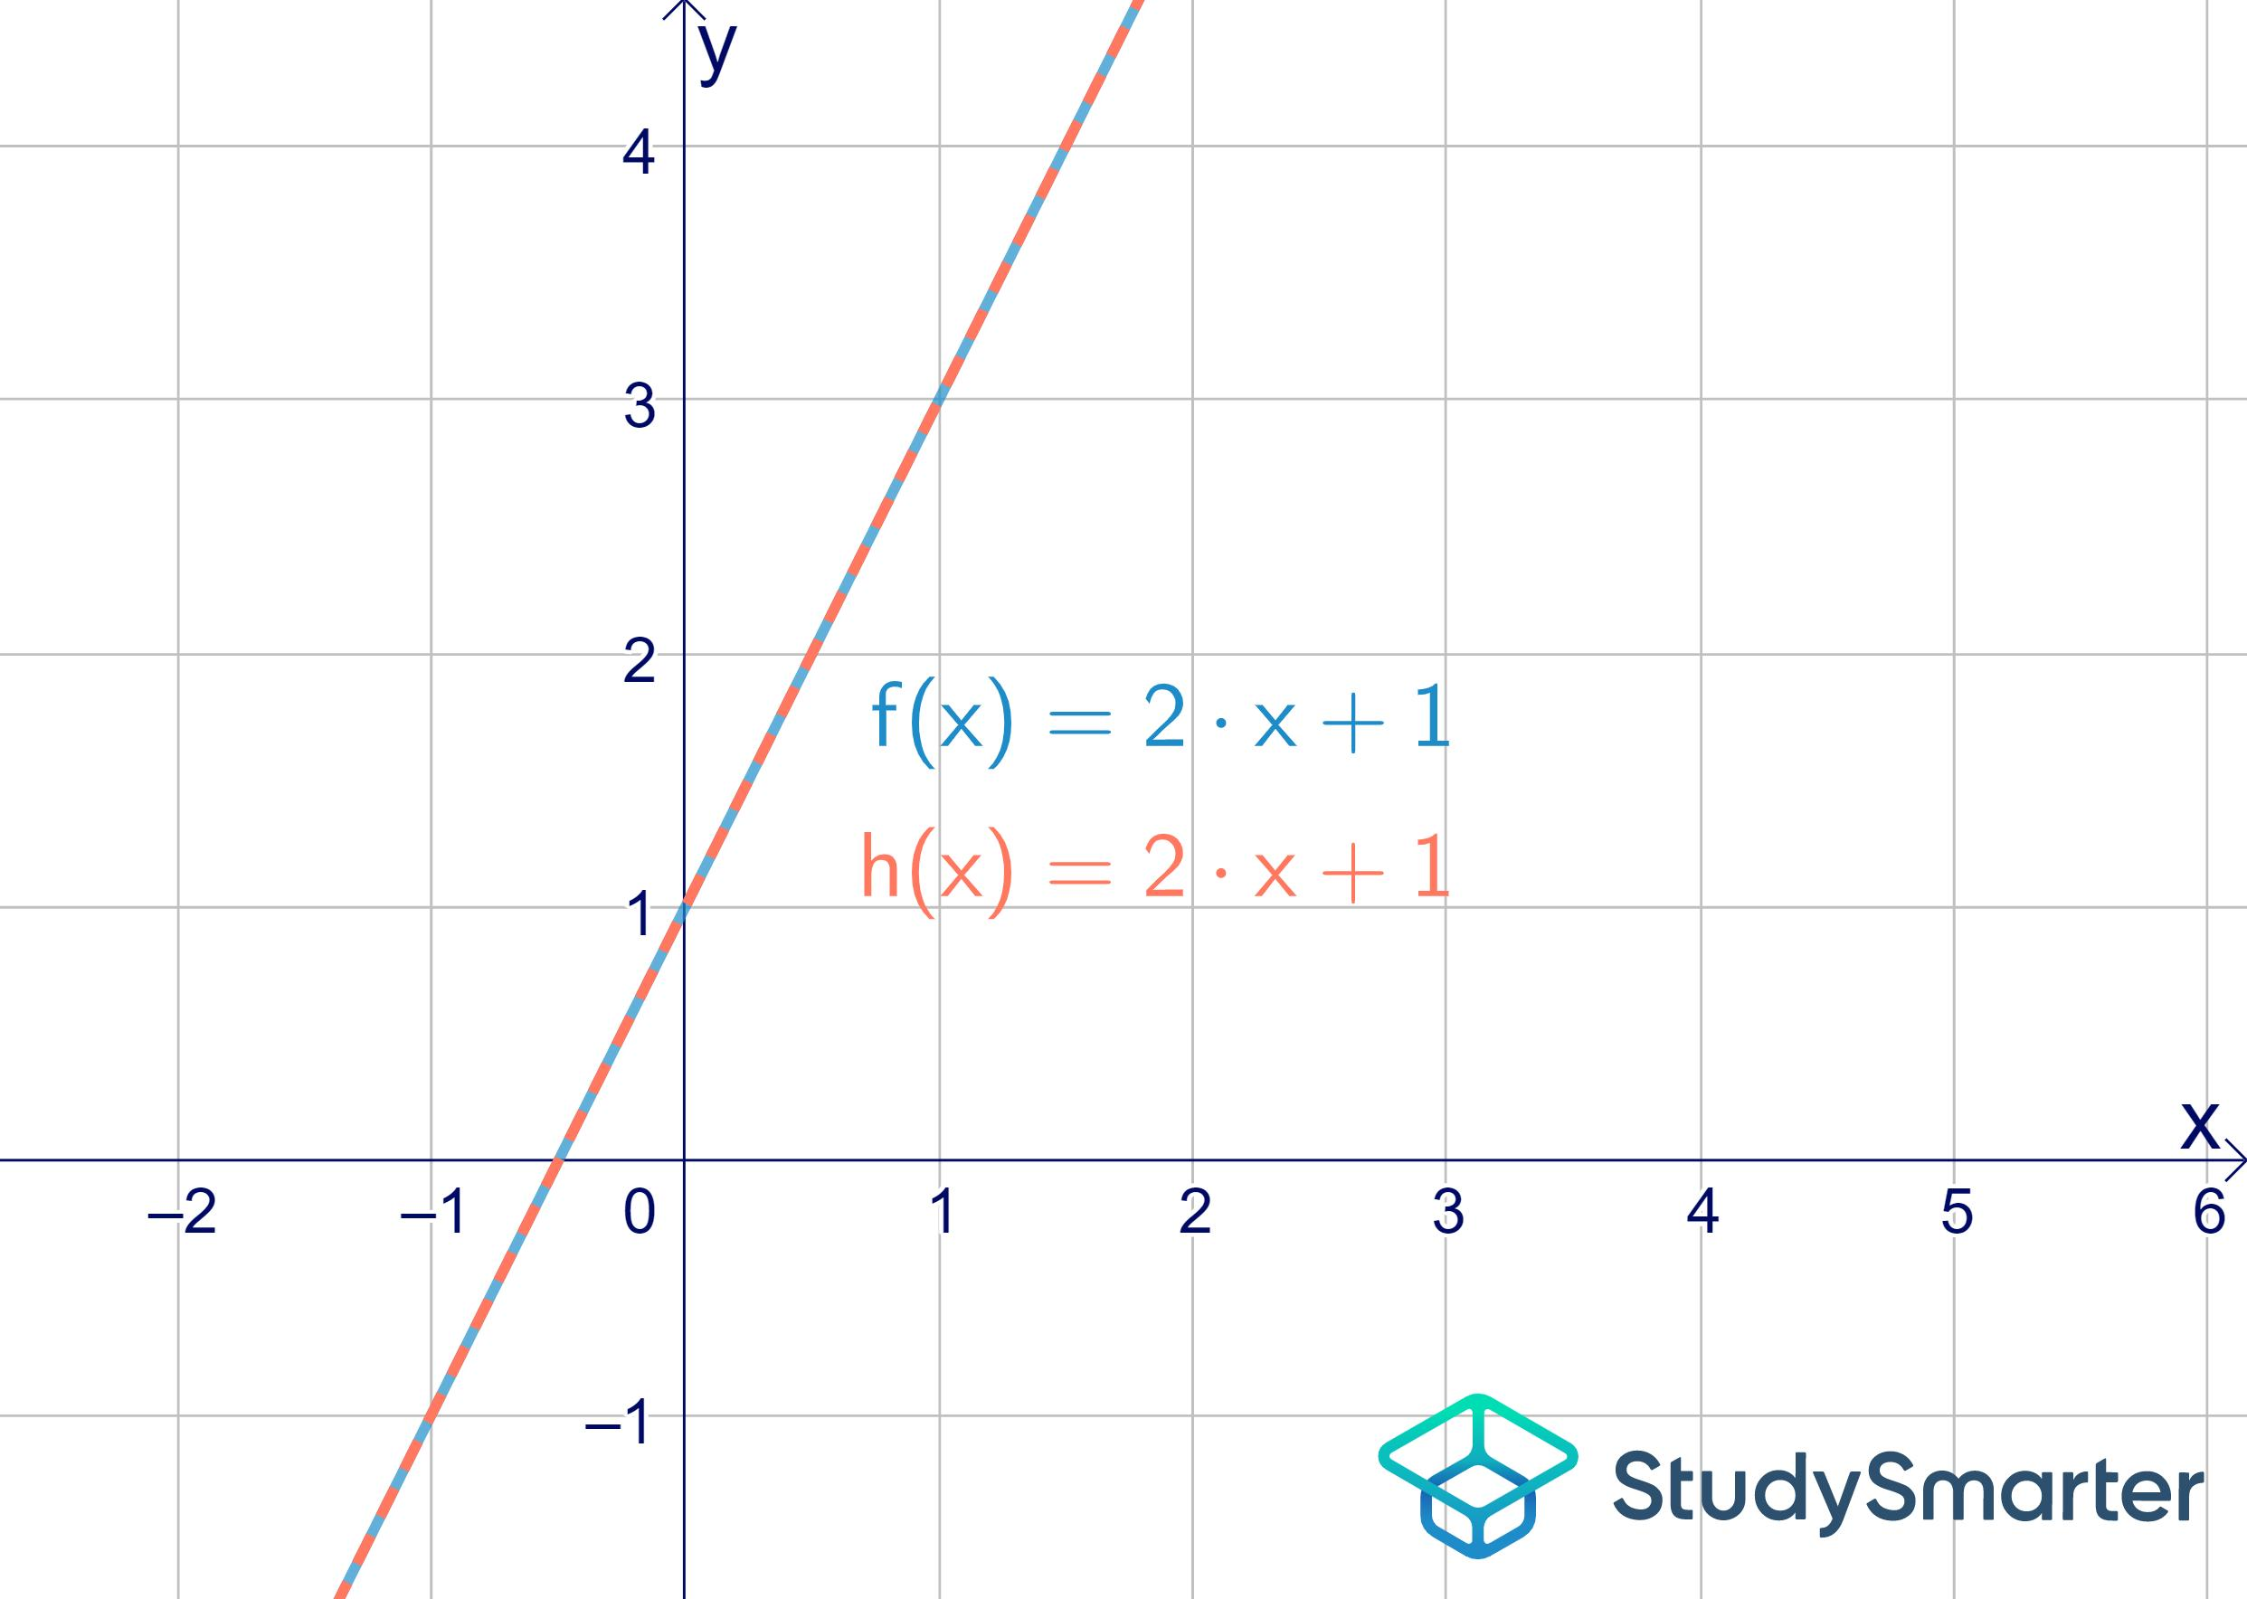
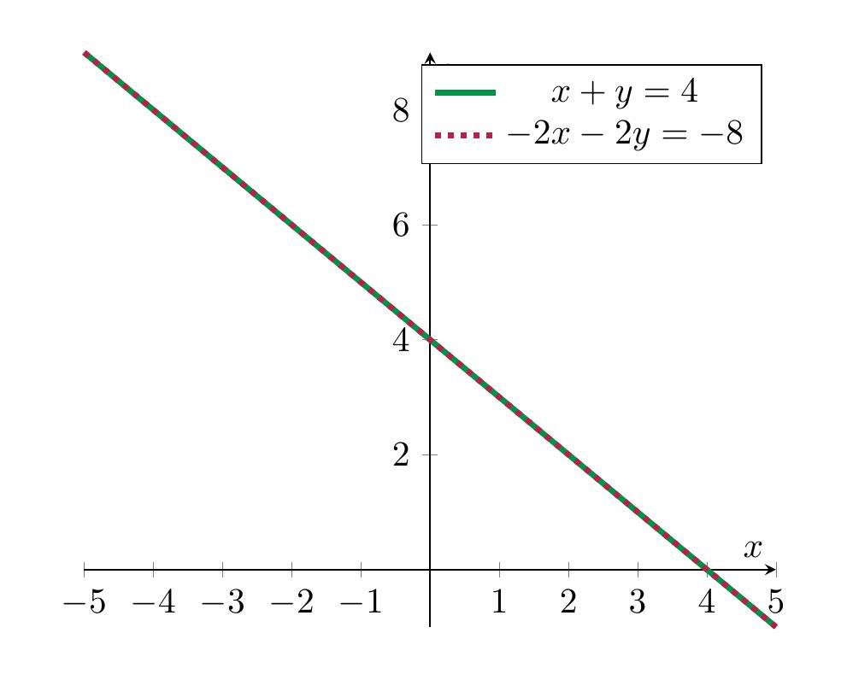
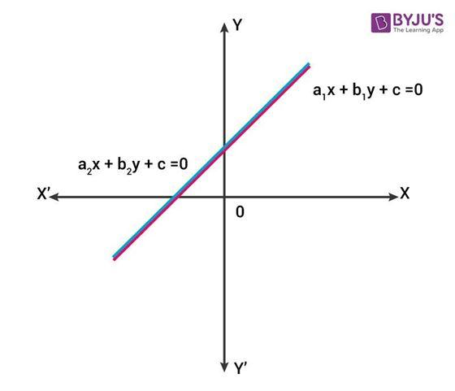
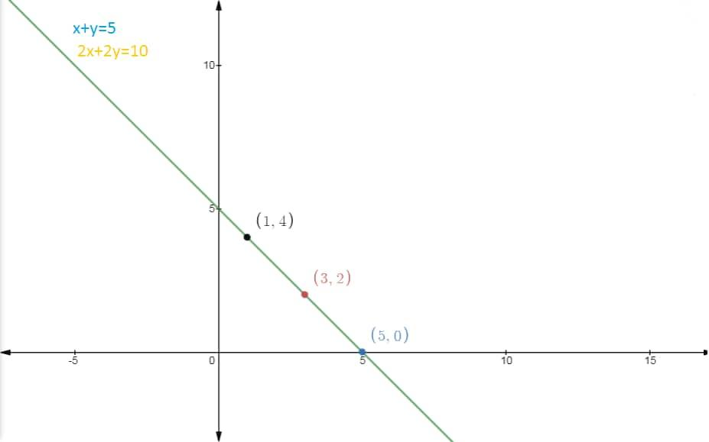

Coincident Horizontal Lines
# Source: AI Source: Provided by: [Data Path: Persons Table -> ID Column: 1, Name_En Column: Motasem Essam] -> From: [ChatGPT] on [7/25/2026]
For example:
$$y=4$$
and:
$$2y=8$$
The second equation simplifies to:
$$y=4$$
Therefore:
$$\boxed{y=4}$$
is the same line in both cases.

Coincident Vertical Lines
# Source: AI Source: Provided by: [Data Path: Persons Table -> ID Column: 1, Name_En Column: Motasem Essam] -> From: [ChatGPT] on [7/25/2026]
For example:
$$x=5$$
and:
$$2x=10$$
The second equation simplifies to:
$$x=5$$
Therefore, they represent the same vertical line:
$$\boxed{x=5}$$

Coincident Segments on a Number Line
# Source: AI Source: Provided by: [Data Path: Persons Table -> ID Column: 1, Name_En Column: Motasem Essam] -> From: [ChatGPT] on [7/25/2026]
Consider:
$$\left[2,8\right]$$
and:
$$\left[2,8\right]$$
They are identical intervals.
Therefore:
$$\boxed{\left[2,8\right]∩\left[2,8\right]=\left[2,8\right]}$$
Every number from $2$ through $8$ belongs to both intervals.

Coincident Boundaries
# Source: AI Source: Provided by: [Data Path: Persons Table -> ID Column: 1, Name_En Column: Motasem Essam] -> From: [ChatGPT] on [7/25/2026]
Two geometric figures may have exactly the same boundary segment.
For example:
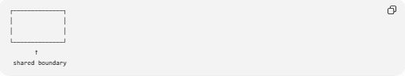
┌──────────────┐
│ │
│ │
└──────────────┘
↑
shared boundary
If another figure has exactly the same boundary portion, that portion is coincident.
This is especially important when multiple geometric objects share the same boundary.

Coincident Polygon Edges
# Source: AI Source: Provided by: [Data Path: Persons Table -> ID Column: 1, Name_En Column: Motasem Essam] -> From: [ChatGPT] on [7/25/2026]
Two polygons can have edges that are completely coincident.
For example:
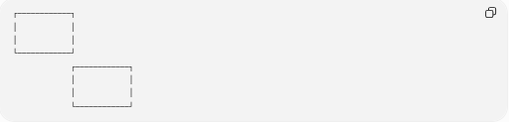
┌────────────┐
│ │
│ │
└────────────┘
┌────────────┐
│ │
│ │
└────────────┘
If the polygons share an entire edge, that edge is coincident.
Mathematically:
$$\boxed{E_{1}∩E_{2}=E_{1}=E_{2}}$$
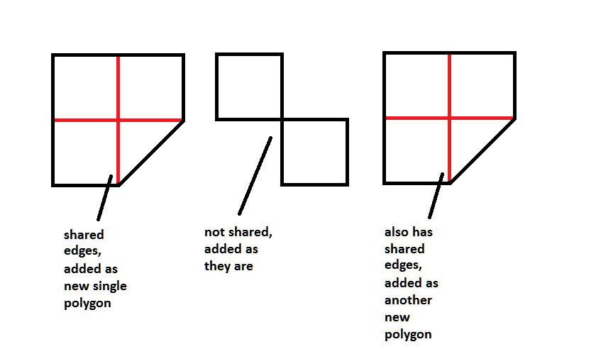
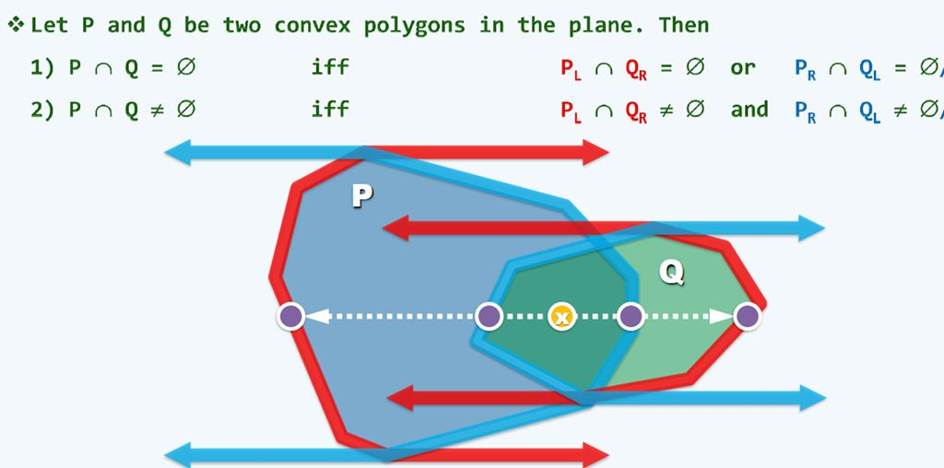

Coincident Polylines
# Source: AI Source: Provided by: [Data Path: Persons Table -> ID Column: 1, Name_En Column: Motasem Essam] -> From: [ChatGPT] on [7/25/2026]
Two polylines may contain identical segments.
For example:
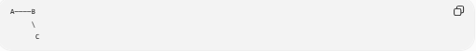
A────B
\
C
If another polyline follows exactly the same path:
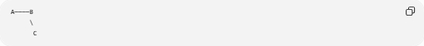
A────B
\
C
the corresponding segments are coincident.
Coincident polylines are especially important in:
- GIS.
- CAD.
- Mapping.
- Computer graphics.
- Route analysis.
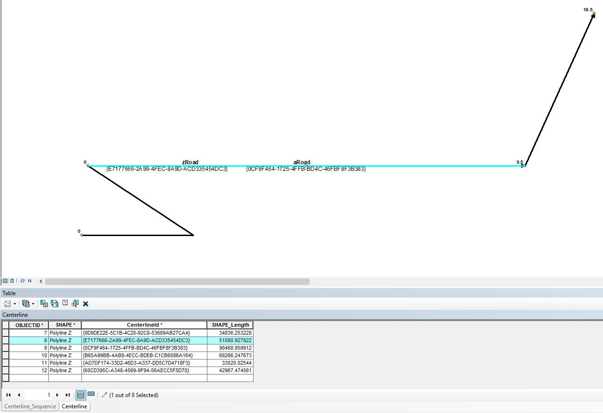
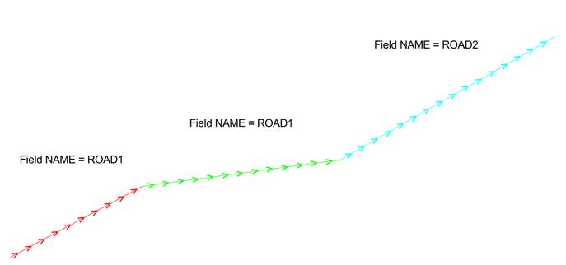
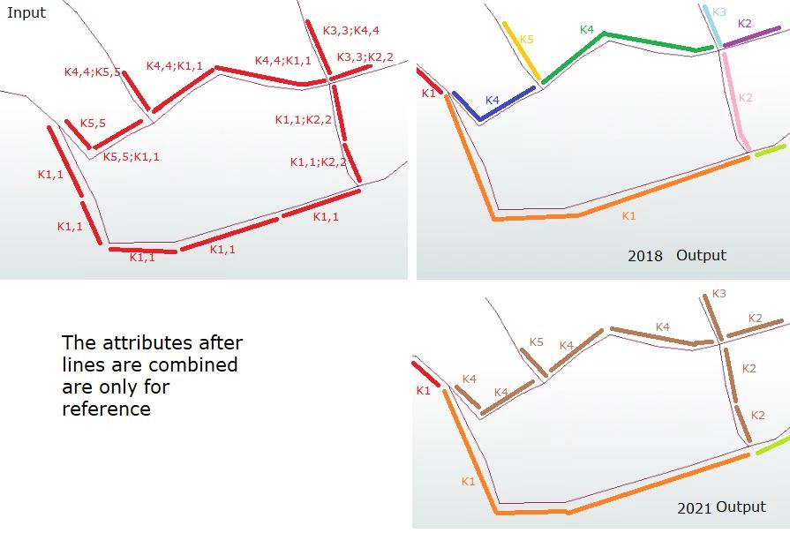

Coincident Intersection in CAD
# Source: AI Source: Provided by: [Data Path: Persons Table -> ID Column: 1, Name_En Column: Motasem Essam] -> From: [ChatGPT] on [7/25/2026]
In CAD, duplicate lines can occupy exactly the same position.
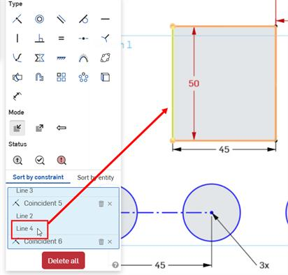
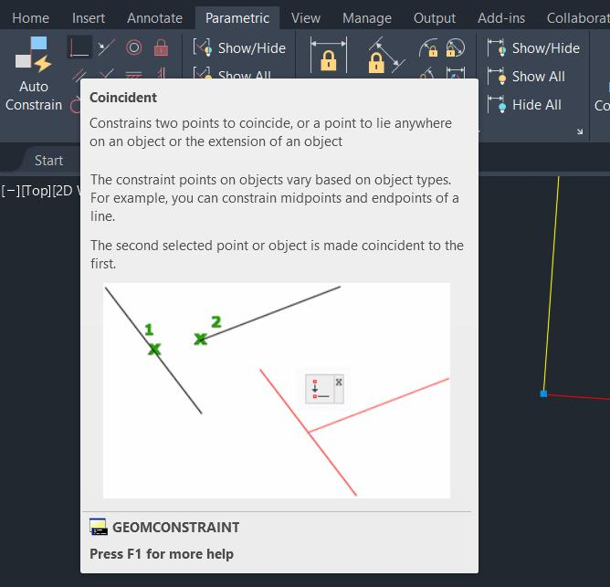
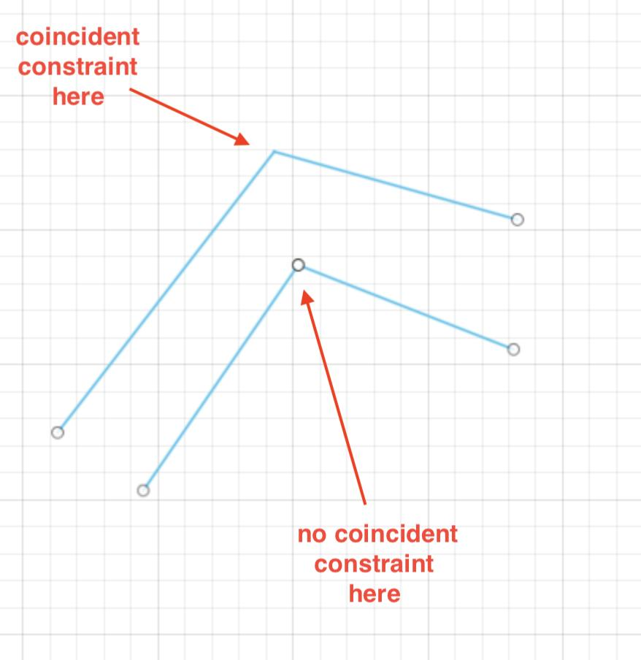
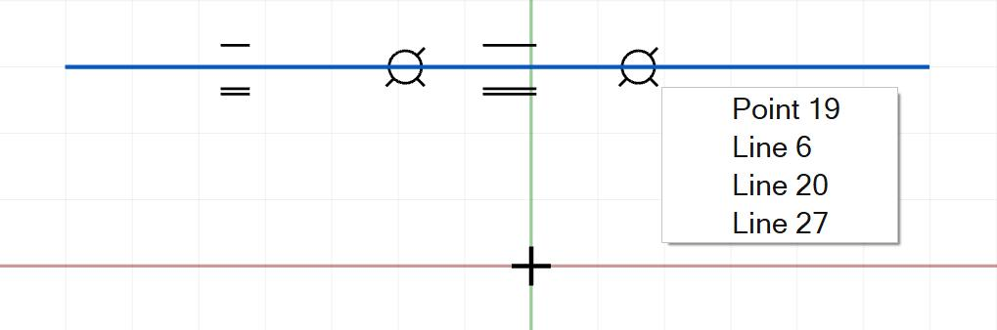
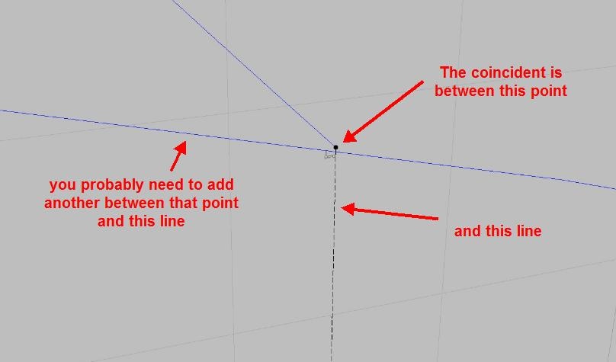
Detecting coincident geometry helps to:
- Remove duplicate lines.
- Clean drawings.
- Prevent duplicate edges.
- Simplify models.
- Create accurate boundaries.
- Improve geometric calculations.

Coincident Intersection in GIS
# Source: AI Source: Provided by: [Data Path: Persons Table -> ID Column: 1, Name_En Column: Motasem Essam] -> From: [ChatGPT] on [7/25/2026]
GIS data may contain duplicate or coincident boundaries.
For example:
- Two administrative regions may share a boundary.
- Two datasets may contain the same road.
- Two map layers may contain identical line features.
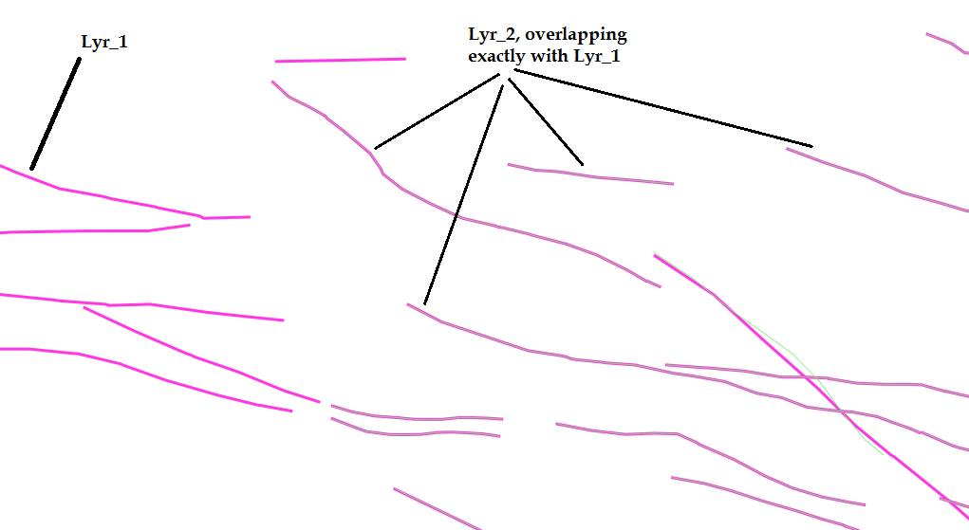
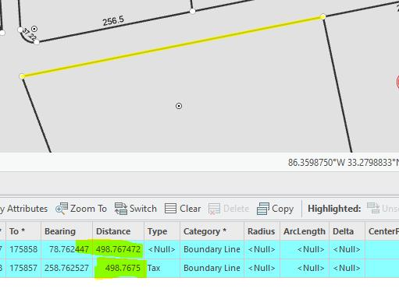
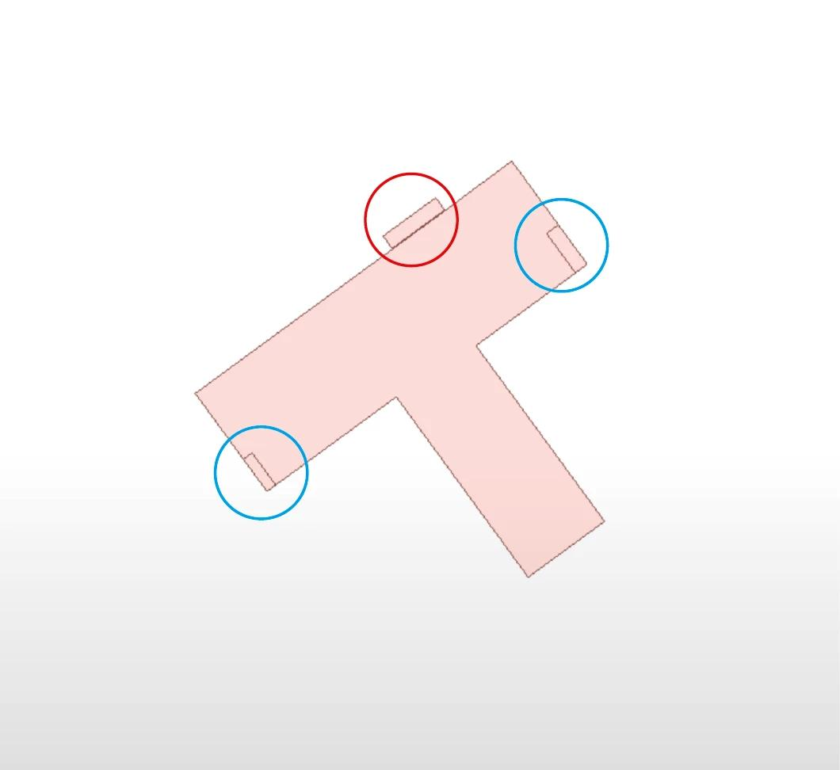
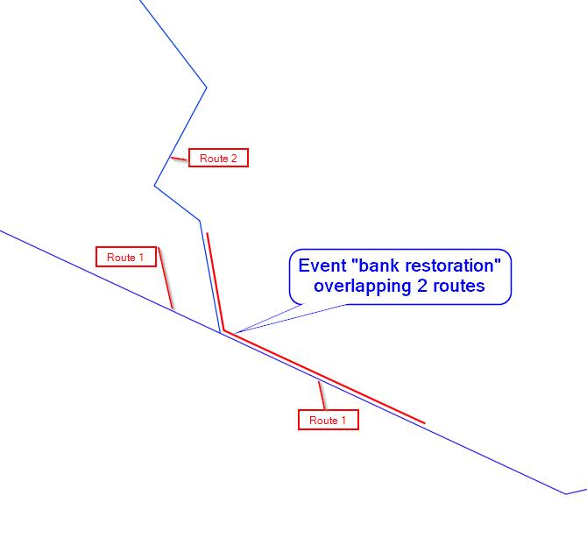
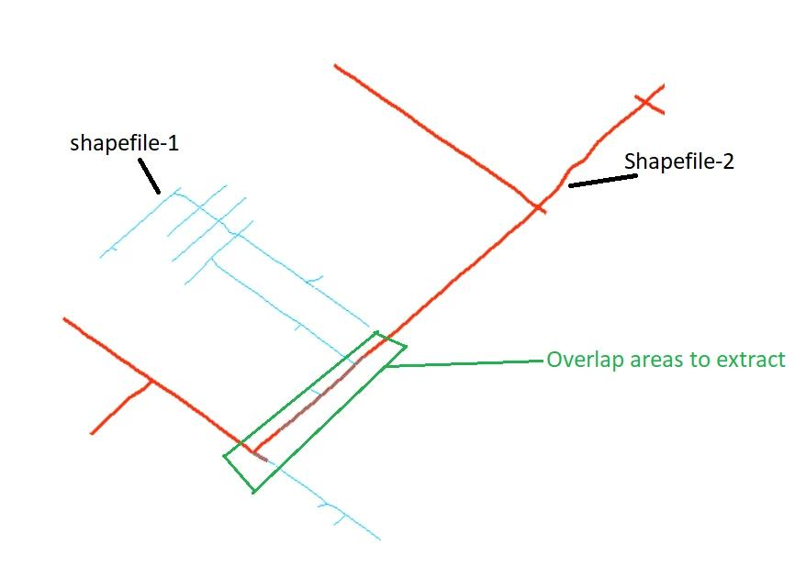
Detecting coincident geometry helps prevent duplicated geographic data.

Coincident Intersection in Computer Graphics
# Source: AI Source: Provided by: [Data Path: Persons Table -> ID Column: 1, Name_En Column: Motasem Essam] -> From: [ChatGPT] on [7/25/2026]
Coincident geometry can occur when two graphical objects occupy exactly the same location.
This can cause a visual problem called z-fighting in 3D computer graphics when surfaces occupy the same depth.
In 2D vector graphics, coincident paths can also create duplicate rendering or selection problems.
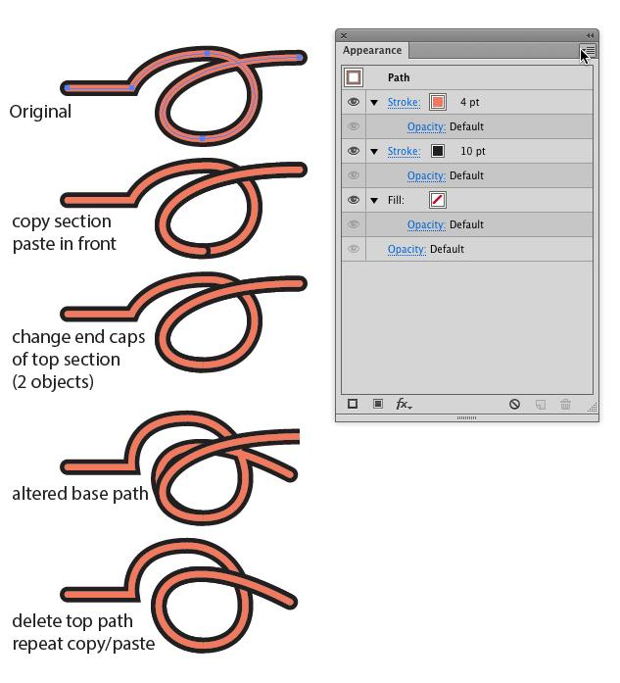
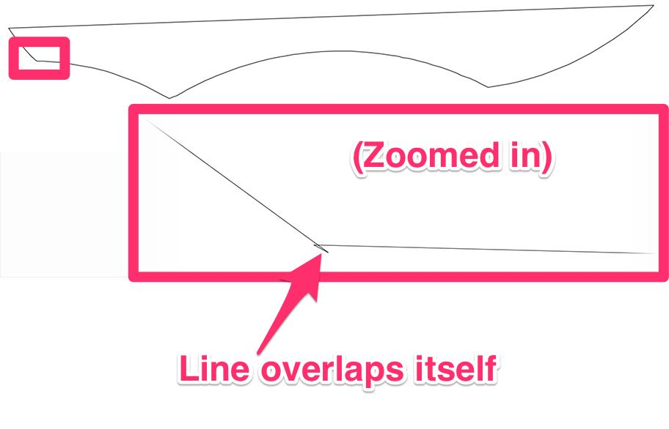
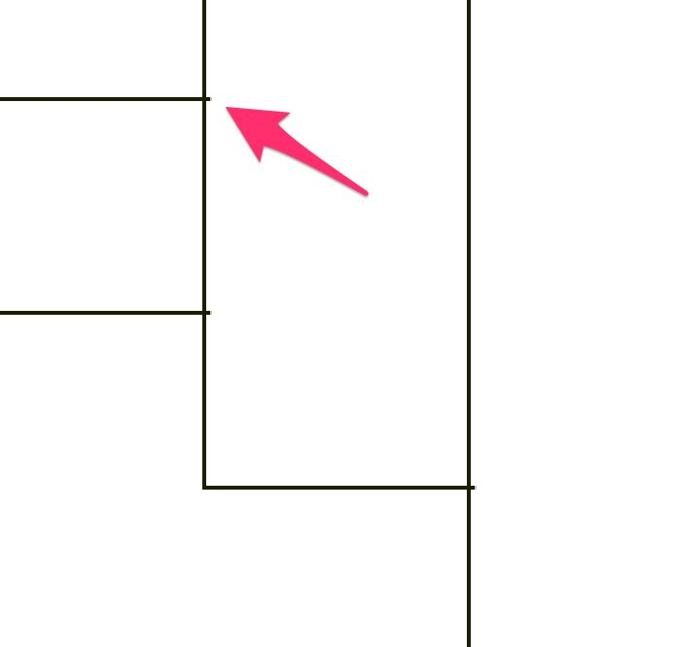

Real-World Examples
# Source: AI Source: Provided by: [Data Path: Persons Table -> ID Column: 1, Name_En Column: Motasem Essam] -> From: [ChatGPT] on [7/25/2026]
Coincident geometry can represent:
- Two maps containing the exact same road.
- Two CAD lines representing the same wall.
- Two boundaries occupying the same path.
- Two routes following exactly the same geometric path.
- Duplicate edges in a digital model.
- Two drawings containing the same geometric object.

Applications
# Source: AI Source: Provided by: [Data Path: Persons Table -> ID Column: 1, Name_En Column: Motasem Essam] -> From: [ChatGPT] on [7/25/2026]
Coincident Intersection is important in:
- Plane Geometry
- Coordinate Geometry
- Computational Geometry
- Polygon Theory
- Polyline Geometry
- CAD
- GIS
- Cartography
- Architecture
- Engineering
- Computer Graphics
- Robotics
- Mapping
- Surveying

Advantages
# Source: AI Source: Provided by: [Data Path: Persons Table -> ID Column: 1, Name_En Column: Motasem Essam] -> From: [ChatGPT] on [7/25/2026]
Studying coincident intersections helps to:
- Identify identical geometric objects.
- Detect duplicate geometry.
- Simplify geometric models.
- Identify shared boundaries.
- Clean CAD drawings.
- Remove duplicate GIS features.
- Improve computational geometry algorithms.
- Detect identical paths and edges.

Limitations
# Source: AI Source: Provided by: [Data Path: Persons Table -> ID Column: 1, Name_En Column: Motasem Essam] -> From: [ChatGPT] on [7/25/2026]
Coincident intersections:
- Can be difficult to distinguish from partial overlap.
- May create duplicate geometry in digital systems.
- Require accurate coordinate comparisons.
- Can cause problems in CAD and GIS data if duplicates are not removed.
- May require tolerance values when working with floating-point coordinates.

Comparison with Related Concepts
# Source: AI Source: Provided by: [Data Path: Persons Table -> ID Column: 1, Name_En Column: Motasem Essam] -> From: [ChatGPT] on [7/25/2026]
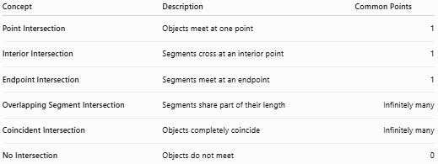
Concept | Description | Common Points
Point Intersection | Objects meet at one point | 1
Interior Intersection | Segments cross at an interior point | 1
Endpoint Intersection | Segments meet at an endpoint | 1
Overlapping Segment Intersection | Segments share part of their length | Infinitely many
Coincident Intersection | Objects completely coincide | Infinitely many
No Intersection | Objects do not meet | 0

Important Relationship
# Source: AI Source: Provided by: [Data Path: Persons Table -> ID Column: 1, Name_En Column: Motasem Essam] -> From: [ChatGPT] on [7/25/2026]
Coincident intersection can be considered a special case of complete overlap.
For example:
$$\overline{AB}=\overline{CD}$$
means the two segments have exactly the same points.
Therefore:
$$\boxed{\overline{AB}∩\overline{CD}=\overline{AB}=\overline{CD}}$$
So:
$$\boxed{\text{Coincident Intersection}=\text{Complete Geometric Coincidence}}$$

Intersection Classification
# Source: AI Source: Provided by: [Data Path: Persons Table -> ID Column: 1, Name_En Column: Motasem Essam] -> From: [ChatGPT] on [7/25/2026]
The main intersection cases can be organized as:
$$\boxed{\begin{aligned}\text{No Intersection}&→∅ \\ \text{Point Intersection}→P \\ \text{Endpoint Intersection}→P \\ \text{Interior Intersection}→P \\ \text{Overlapping Intersection}→\overline{PQ} \\ \text{Coincident Intersection}&→\text{Entire Object}\end{aligned}}$$
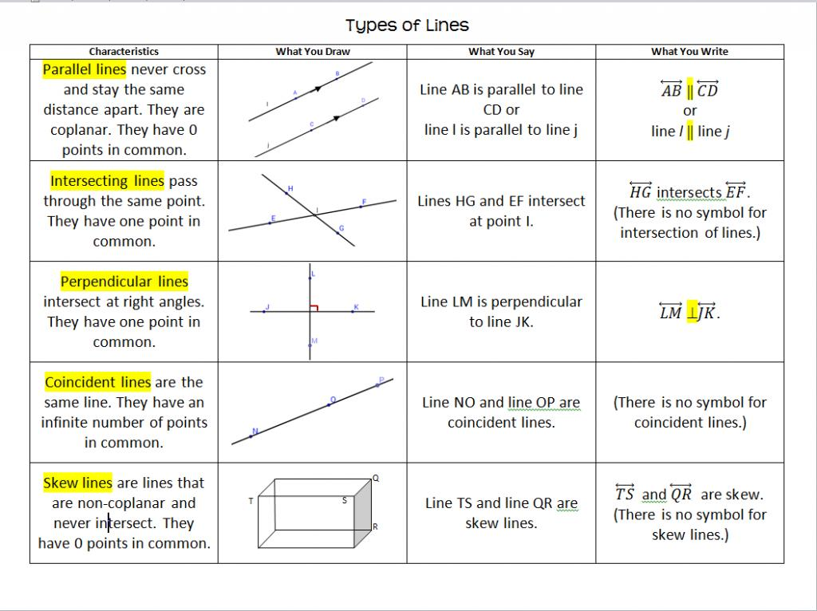
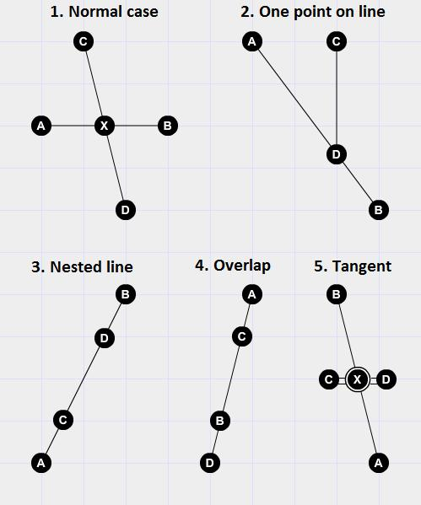
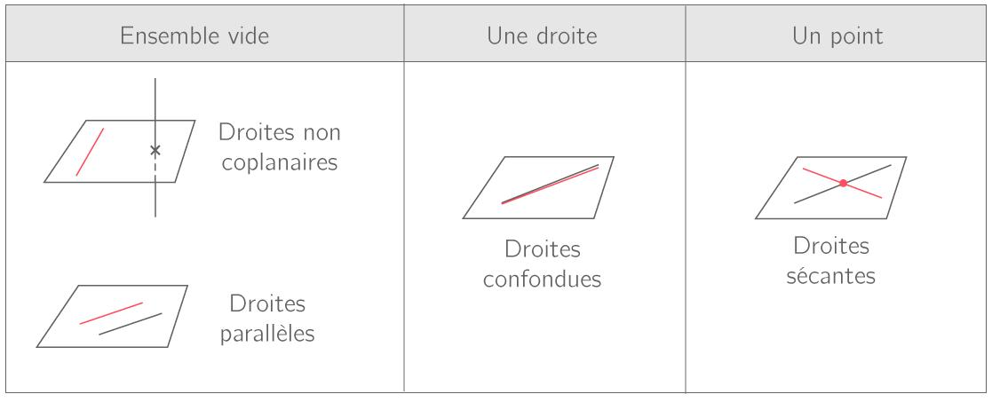

Key Points
# Source: AI Source: Provided by: [Data Path: Persons Table -> ID Column: 1, Name_En Column: Motasem Essam] -> From: [ChatGPT] on [7/25/2026]
- Coincident Intersection occurs when two geometric objects occupy exactly the same location.
- Every point of one object belongs to the other.
- For identical segments:
$$\boxed{\overline{AB}∩\overline{CD}=\overline{AB}}$$
when:
$$\boxed{\overline{AB}=\overline{CD}}$$
- Coincident lines have infinitely many common points.
- Coincident segments are completely overlapping, not partially overlapping.
- Coincident geometry is important in CAD, GIS, coordinate geometry, computational geometry, and computer graphics.
- Coincident objects can represent either intentionally shared geometry or accidental duplicate geometry.

Conclusion
# Source: AI Source: Provided by: [Data Path: Persons Table -> ID Column: 1, Name_En Column: Motasem Essam] -> From: [ChatGPT] on [7/25/2026]
Coincident Intersection occurs when two geometric objects completely coincide, meaning they occupy exactly the same set of points. Unlike a point intersection, which contains only one common point, a coincident intersection contains the entire geometric object. Two identical line segments, rays, lines, or boundaries can therefore have a coincident intersection. This concept is particularly important in plane geometry, coordinate geometry, computational geometry, CAD, GIS, surveying, mapping, engineering, and computer graphics, where identifying identical and duplicate geometric elements is essential.

